B. In-Depth Explanation & Analysis
1. Nomadic Herding vs. Commercial Livestock Rearing
- Nomadic Herding: Primitive, subsistence-based. Herders move with animals looking for natural pasture. No tech, no fences. (e.g., Tribes in Tundra or Sahara).
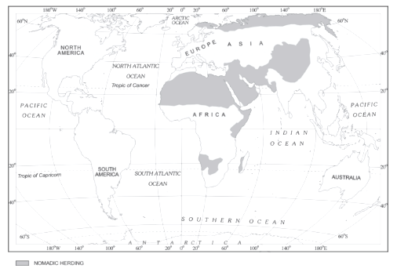
- Commercial Livestock Rearing: Modern, profit-based. Animals kept on huge fenced ranches. Scientific breeding, healthcare. Focused on one type of animal (sheep/cattle) for meat/wool for export. (e.g., Ranches in Australia, USA).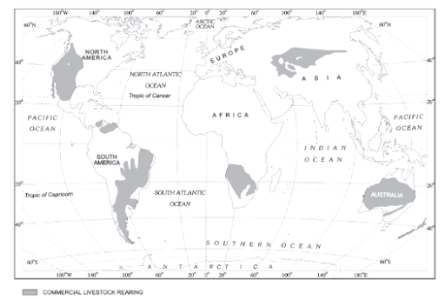

2. Intensive Subsistence vs. Extensive Commercial Agriculture
- Intensive Subsistence (e.g., Rice in India/China): Small land holdings, huge labor input (entire family works), low machine use, high yield per unit land but low yield per person. Priority is feeding a dense population.
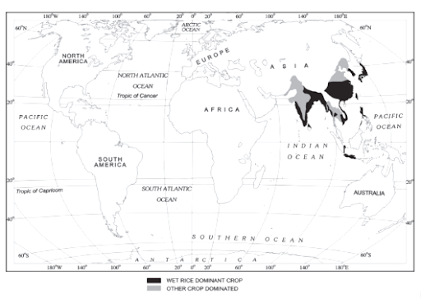
- Extensive Commercial (e.g., Wheat in USA/Canada): Huge farms, highly mechanized (combines), low labor input, moderate yield per acre but massive yield per person. Priority is profit and export.
3. Footloose Industries Most industries are tied to raw materials (like steel plants near iron mines) or markets. Footloose industries are different. They don't depend heavily on specific raw materials (often use light, easily transportable components) and can be located almost anywhere, often favoring pleasant environments near roads. Examples: Electronics, software.
4. The "Rust Bowl" Concept Refers to old industrial regions (like around Pittsburgh, USA) that were once booming with heavy steel/iron industries but declined. Factories closed down, leaving behind rusting machinery and high unemployment.
Mentor’s insight:
- For 4th chapter maps are very important, so make sure to do a thorough revision of maps once before exams along with what activities are practiced in what areas is very crucial to remember.
- Different terms used for shifting cultivation in different regions of the world for example Jhuming in North eastern states of India, Milpa in central America and Ladang in Indonesia and Malaysia are often asked in MCQs.
- Which plantation crop was established in which country by which European colonial authority is also important.
- Kolkhoz model of collective farming was introduced in erstwhile Soviet Union.
- Methods of mining are a must to revise (open-cast mining and shaft mining).
- Factors influencing industrial location, and industries based on raw material are often asked.
- 5th chapter is quiet an easy one, a few topics like high tech industries, industries based on size (household industries, small scale industries and large scale industries) and topics mentioned in above point will help you score well.

